Monday: Prayer Hands
- marker
- construction paper
- scissors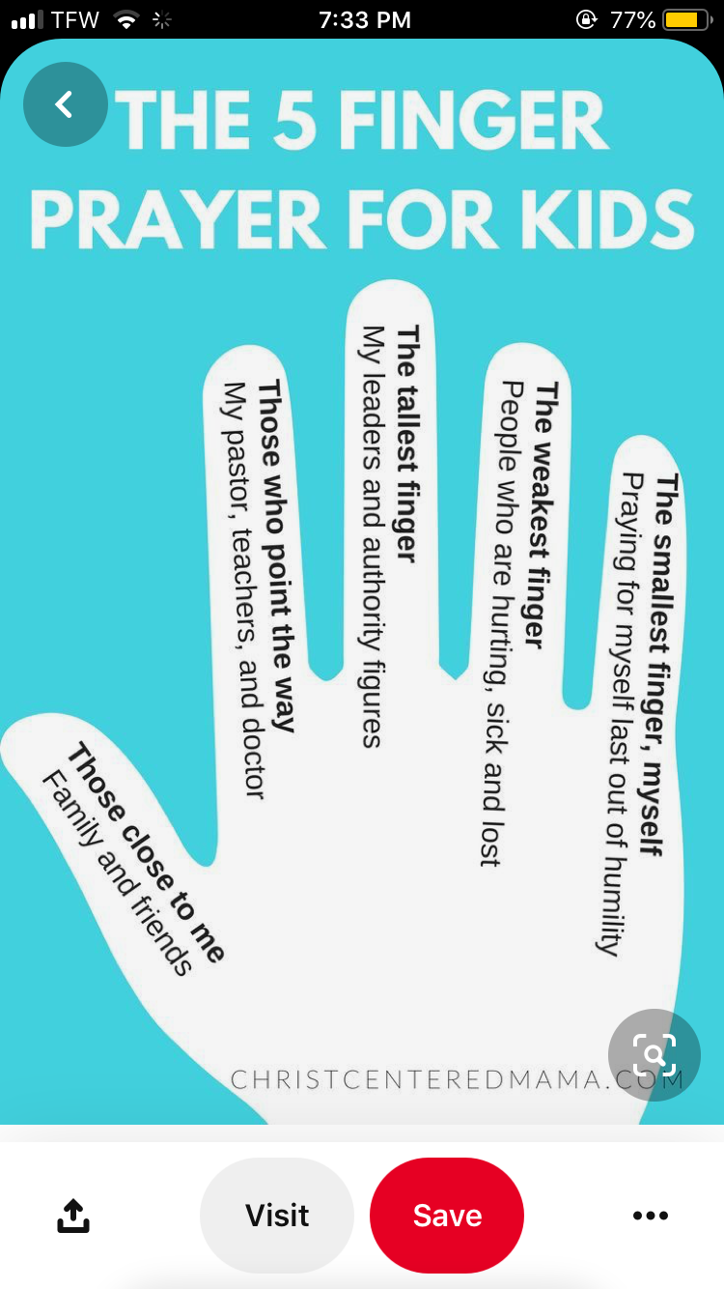
Tuesday: Caterpillar Name
- scissors
- marker
- construction paper
e

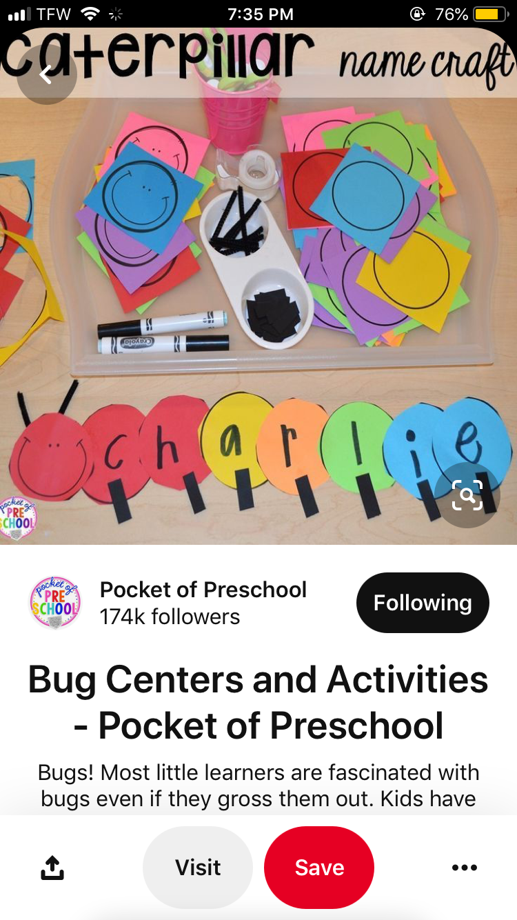

Wednesday: Popsicle
- popsicle sticks
- Pom Pom’s
- Glitter
- glue
- construction paper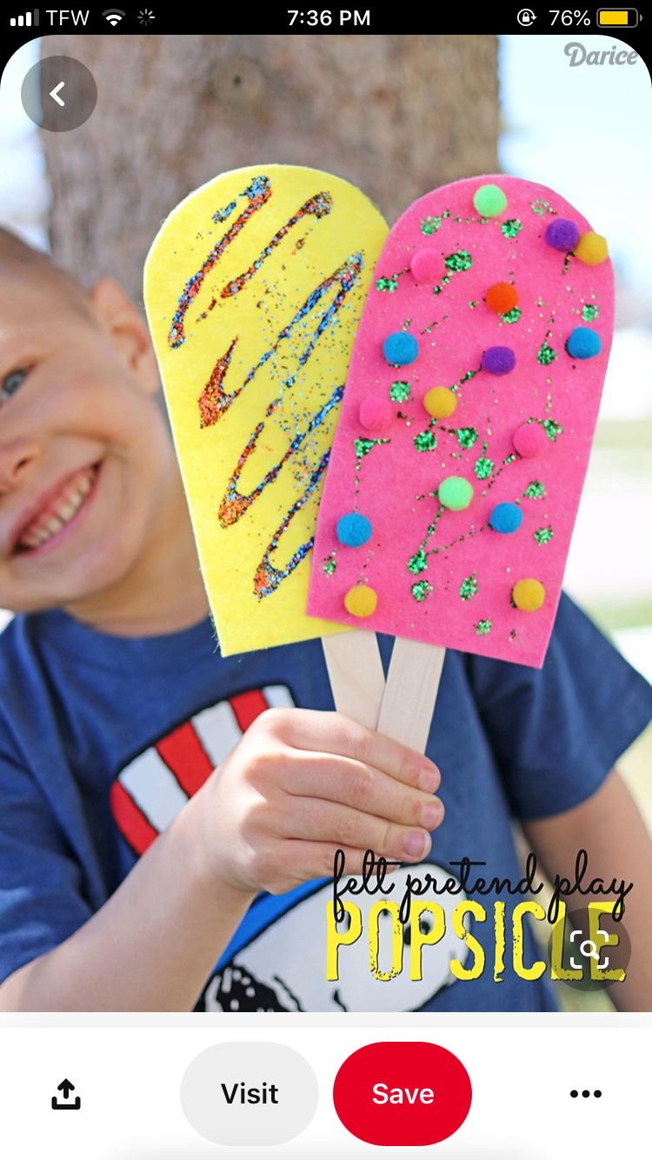
Thursday: Cross Craft
- popsicle sticks
- hot glue
- buttons
- gems 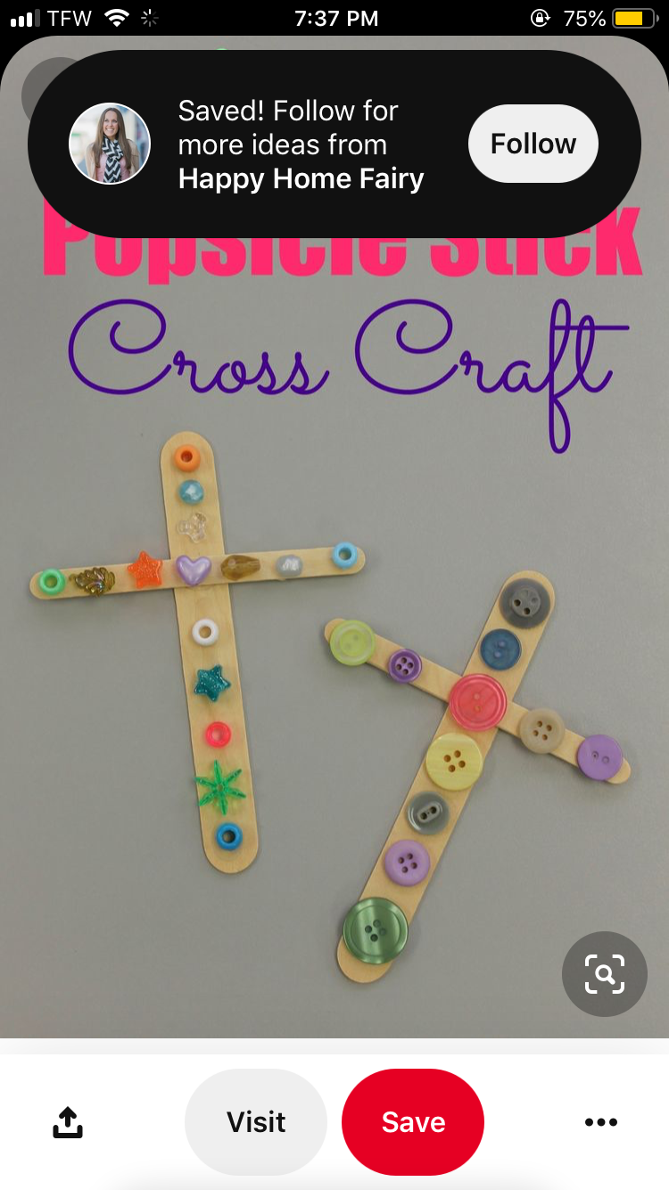
Friday: Cars
- markers
- paint
- hot glue
- buttons
- stickers
- gems
- scissors
